**Practical Task “Requirements Analysis”**

Today we suggest you do some of the most common test task - requirements analysis for the provided web-form.

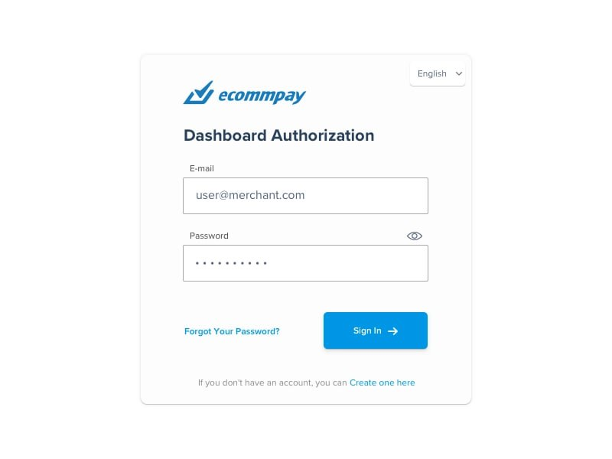

Requirements:

1. “Ecommpay” application provides users with the possibility to sign up and log in into the app using the Authorization form.

2. The authorization web-form contains the following input fields:

2.1. “E-mail”

2.2. “pasword” (grammar mistake).

What min and max length? What symbols, letters, and numbers do we have to use? What if the password would not fit in the field

2.3. “Sign In” button this is not an input field.

and should allow users to select the language to be used.

What languages do we have to add? What kind of language list should it be?

3. The authorization web-form should also contain the link “Forgot your pasword?” to reset the pasword What procedure for resetting a password? and the text “If you don’t have an account, you can create one here”. “Create one here” should be a link as well and lead to sign up form after clicking it.

I guess sign up form is shown on next page…

4. The authorization web-form allows users to show/hide the pasword input using ‘Eye’ icon above the “Pasword” field.

5. The form should be created in the colors of the company - white and blue. Clarify the RAL of white and blue.

Elements sizes? Authorization form size?

*original text

*edits